TROUBLESHOOT BASICS

PRESENTED BY

BALA SREEKUMAR

Table of Contents

Why is my mouse not working 3

Possible Causes 3

Troubleshooting Steps 3

Why is my monitor showing a black screen when connected to my laptop? 4

Possible Causes 4

Troubleshooting Steps 4

Why is my computer very slow, it’s a new laptop? 5

Possible Causes 5

Troubleshooting Steps 5

How can I connect my printer to my laptop? 6

For a Wired Printer 6

For a Wireless Printer: 6

Glossary 7

References 7

Image Courtesy 7

# Why is my mouse not working

(Easytechgeek)



## Possible Causes

* Connection Issues (loose cables, low battery, unpaired wireless connection).
* Driver Problems (outdated or corrupted mouse drivers).
* Hardware Failures (faulty mouse or USB port).

## Troubleshooting Steps

* Check Physical Connections: Ensure the mouse is properly plugged in, replace batteries for wireless mice, and make sure it’s powered on.
* Test the Mouse on Another Device: Connect to another PC to check if it works.
* Try a Different Mouse: If another mouse works, the issue is with the original device.
* Inspect USB Ports: Test different USB ports to rule out port issues.
* Update or Reinstall Mouse Drivers: Use Device Manager to update or reinstall drivers.
* Check for Windows Updates: Install any available updates.
* Scan for Malware: Run a full system scan with antivirus software.

[More Troubleshooting Steps](https://support.microsoft.com/en-us/windows/mouse-and-keyboard-problems-in-windows-94b4ca7b-4f2f-077e-4eb4-f7b4ecdf4f61)

# Why is my monitor showing a black screen when connected to my laptop?

(TechLunar)

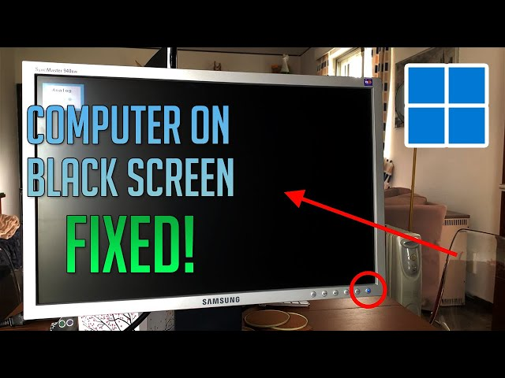

## Possible Causes

* Loose or faulty cable connection.
* Wrong input source selection.
* Incorrect display settings.
* Outdated graphics drivers.

## Troubleshooting Steps

* Check Physical Connections: Ensure cables are firmly connected and undamaged.
* Check Monitor Power: Verify that the monitor is powered on.
* Select the Correct Input Source: Use the monitor’s menu to select the right input.
* Test with Another Device: Connect the monitor to a different laptop.
* Use a Different Cable: Try a new HDMI/DisplayPort cable.
* Adjust Display Settings: Use Win + P to change display modes.
* Update or Reinstall Graphics Drivers: Use Device Manager to update drivers.

[More Display Issue Fixes](https://support.microsoft.com/en-us/help/4023496/windows-10-troubleshoot-black-screen-or-blank-screen-errors)

# Why is my computer very slow, it’s a new laptop?

(Passingham)



## Possible Causes

* Too many background processes.
* Windows updates or indexing in progress.
* Pre-installed bloatware slowing performance.

## Troubleshooting Steps

* Restart the Laptop.
* Check Task Manager: Use Ctrl + Shift + Esc to check for high resource usage.
* Disable Startup Programs: Disable unnecessary startup apps in Task Manager.
* Run Disk Cleanup: Use File Explorer to remove junk files.
* Update Windows & Drivers: Keep the system updated.
* Scan for Malware: Run a full system scan.
* Adjust Performance Settings: Optimize Windows for best performance.

[Improve PC Performance](https://support.microsoft.com/en-us/windows/tips-to-improve-pc-performance-in-windows-10-60c6d27c-2b73-49f9-4c44-5862b1baf937)

# How can I connect my printer to my laptop?

(Rankviz)

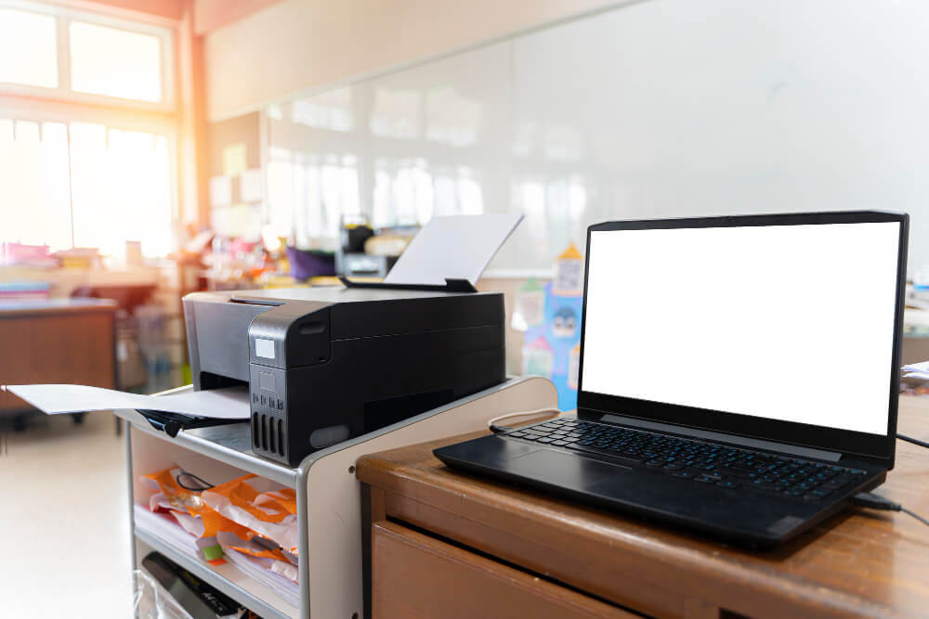

## For a Wired Printer

* Connect via USB and let Windows auto-detect the printer.
* If not detected, go to Settings > Devices > Printers & Scanners > Click Add a printer.

## For a Wireless Printer:

* Ensure the printer is connected to Wi-Fi.
* On your laptop, go to Settings > Devices > Printers & Scanners.
* Click Add a printer or scanner and select your printer.
* Download drivers from the manufacturer’s website if needed.

[Set Up a Printer in Windows](https://support.microsoft.com/en-us/windows/install-a-printer-in-windows-10-7a30336b-e48a-2b4e-0df5-abe3e3bffdbb)

# Glossary

* Driver: Software that helps hardware communicates with the OS.
* Bloatware: Pre-installed software that may slow down a device.
* Task Manager: A Windows tool to monitor and manage processes.
* HDMI/DisplayPort: Common video cable connections.
* Wi-Fi Printer: A printer that connects wirelessly instead of via cable.

# References

* Microsoft Support - [Mouse and Keyboard Problems](https://support.microsoft.com/en-us/windows/mouse-and-keyboard-problems-in-windows-94b4ca7b-4f2f-077e-4eb4-f7b4ecdf4f61)
* Microsoft Support - [Monitor Black Screen Issues](https://support.microsoft.com/en-us/help/4023496/windows-10-troubleshoot-black-screen-or-blank-screen-errors)
* Microsoft Support - [Improve PC Performance](https://support.microsoft.com/en-us/windows/tips-to-improve-pc-performance-in-windows-10-60c6d27c-2b73-49f9-4c44-5862b1baf937)
* Microsoft Support - [Set Up a Printer](https://support.microsoft.com/en-us/windows/install-a-printer-in-windows-10-7a30336b-e48a-2b4e-0df5-abe3e3bffdbb)

# Image Courtesy

* Easytechgeek. (n.d.). Retrieved from How To Fix Mouse Not Working in Windows 11/Windows 10: https://www.youtube.com/watch?v=t60eeO0NL2s
* Passingham, M. (n.d.). How to speed up a laptop or computer. Retrieved from which: https://www.which.co.uk/reviews/laptops/article/how-to-speed-up-a-slow-computer-aKcRy8S1oufr
* Rankviz, M. (n.d.). inkjetwholesale. Retrieved from How To Connect Canon Printer To Laptop?: https://www.inkjetwholesale.com.au/blog/printer-education/how-to-connect-canon-printer-to-laptop/
* TechLunar. (n.d.). Retrieved from How to Fix: Computer Turns on with Black Screen Monitor | No Display Signal: How to Fix: Computer Turns on with Black Screen Monitor | No Display Signal